Create a GitHub Repository

Purpose
Now that you have created your GitHub profile, you will create your first GitHub repository.
A repository (repo) is a place where you can organize and share files related to a project. In a professional environment, repositories are commonly used to store project files, documentation, analysis, code, and other project materials.
For this assignment, you will create a small professional portfolio repository using work you have already completed in this course.

STEP 1: Create a Hello World repository
- Click on your account name (upper left) to make sure you are at the home page
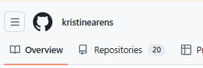
- In the upper right hand, Select the + and click on New Repository
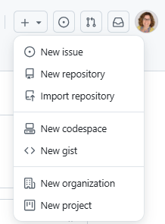
- On the create screen,
  - Add Hello-World as your repository name
  - Add a description (“My first practice repository”)
  - Make sure this is a public repository
  - Turn on the Add README
  - Click on Create Repository
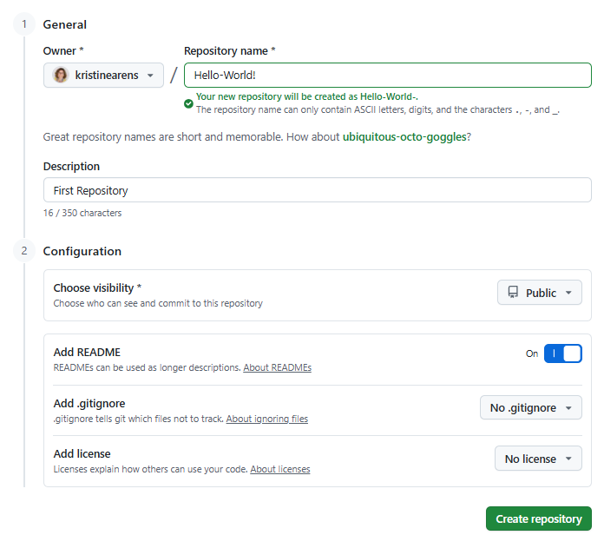
- Once complete, you will have a repository that looks like the below example.
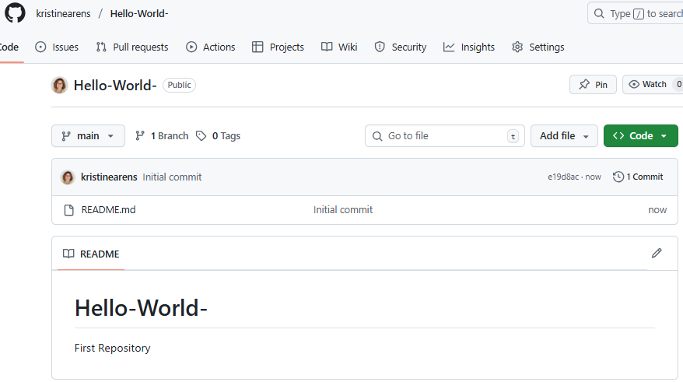

STEP 2: Update the README.md file
- Click on the pencil icon to edit the README.md file.
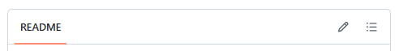

- Update the README.md file using what is called Markdown syntax.
  - Samples of how to use Markdown are found here: Basic writing and formatting syntax
- In your README.md file, you will add the following descriptions:
  - Project Title
  - Description
  - Tools Used
  - Files Used
  - How to Run Program
  - Additional Information
- Below is an example of how you can create your README.md file.
- Once completed, you will Commit Changes
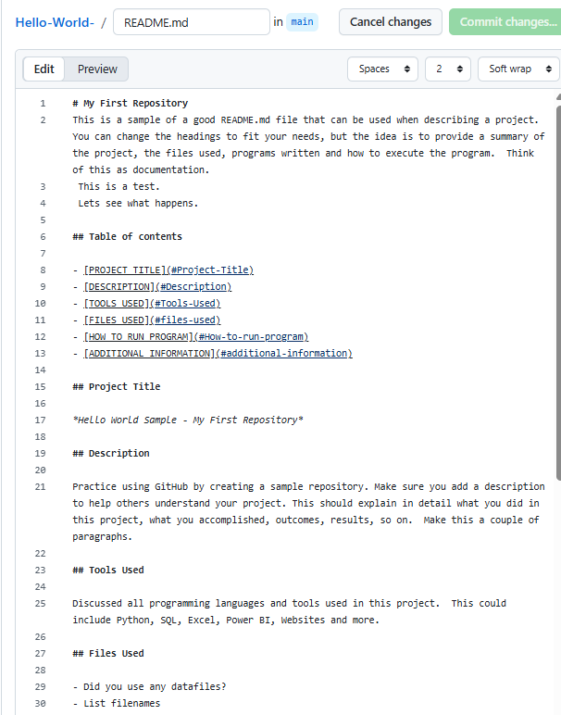

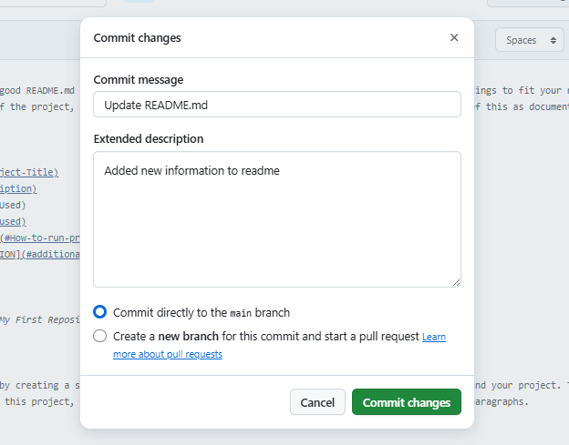
You can look at my GitHub for an example, but try out different heading types, fonts, text styling, lists, and so on. I DO NOT want you to just copy my file. You can even customize the headings a little to fit your style. https://github.com/kristinearens/Hello_World.
** Here are some examples of good README files by other GitHub users: https://github.com/abhisheknaiidu/awesome-github-profile-readme

STEP 3: Upload sample files to repository
- Now it is time to add a couple of sample files to your repository. These are the types of files you might add to your own repository to showcase your knowledge.
- Upload 2 files to your Hello-World repository using the Adding a file to your repository on GitHub instructions. Here’s an example showing all 3 files:

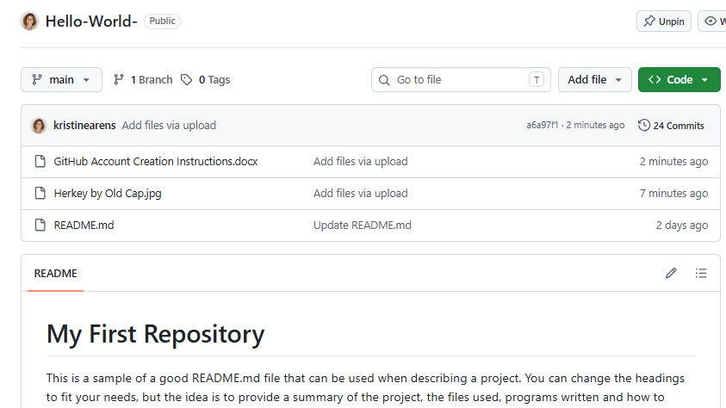

STEP 4: Submit screenshots to assignment
- Time to submit your assignment.
- Follow the directions to submit multiple screenshots showing the 2 files uploaded as well as a completed (committed) README.md file showcasing 4 different markdown syntax.

